

Darshan University

A Project Report on

**“Online Laptop Store”**

Under the subject

**Software Engineering (2301CS405)**

B. Tech, Semester – IV

Computer Science & Engineering Department

|  |  |
| --- | --- |
| Submitted By | |
| Student Name: Dadhaniya Parth | Enrollment No.: 24010101621 |
| Academic Year  (2024-2025) | |
| Internal Guide  Prof. R. B. Gondaliya  Darshan University | Dean-DIET  Dr. Gopi Sanghani  Darshan University |

|  |  |
| --- | --- |
|  | **Computer Science & Engineering Department**  **Darshan University** |

**DECLARATION**

We hereby declare that the SRS, submitted along with the **Software Engineering** **(2301CS405)** for entitled **“Online Laptop Store”** submitted in partial fulfilment for the Semester-5 of **Bachelor Technology (B. Tech)** in **Computer Science and Engineering (CSE)** Departmentto Darshan University, Rajkot, is a record of the work carried out at **Darshan University, Rajkot** under the supervision of R. B. Gondaliya and that no part of any of report has been directly copied from any students’ reports, without providing due reference.

Dadhaniya Parth

Student’s Signature

Date: __________

|  |  |
| --- | --- |
|  | **Computer Science & Engineering Department**  **Darshan University** |

**CERTIFICATE**

This is to certify that the SRS on **“Online Laptop Store” has** been satisfactorily prepared by **Dadhaniya Parth** (**24010101621**) under my guidance in the fulfillment of the course **Software Engineering (2301CS405)** work during the academic year 2024-2025.

|  |  |  |
| --- | --- | --- |
| Internal Guide  Prof. R. B. Gondaliya  Darshan University |  | Dean-DIET  Dr. Gopi Sanghani  Darshan University |

**Acknowledgement**

I wish to express my sincere gratitude to my project guide Prof. R. B. Gondaliyaand all the faculty members for helping me through my project by giving me the necessary suggestions and advices along with their valuable co- ordination in completing this work.

I also thank my parents, friends and all the members of the family for their precious support and encouragement which they had provided in completion of my work. In addition to that, I would also like to mention the Darshan University personals who gave me the permission to use and experience the valuable resources required for the project from the University premises.

Thus, in conclusion to the above said, I once again thank the faculties and members of **Darshan University** for their valuable support in completion of the project.

Thanking You

**Dadhaniya Parth**

**ABSTRACT**

Our online laptop store offers a wide range of laptops to meet the needs of all customers, whether for work, study, gaming, or everyday use. We feature laptops from well-known brands like Dell, HP, Lenovo, and Apple, ensuring quality and reliability. Our easy-to-use website allows customers to browse through various models, compare features, and find the best deals. With options for different budgets, from affordable basic laptops to high-end gaming machines, there's something for everyone. We provide clear product descriptions, reviews, and detailed specifications to help customers make informed decisions. The shopping experience is convenient, with multiple secure payment options and fast shipping to ensure quick delivery of your purchase. Our customer support team is also available to assist with any questions or issues before and after your purchase. Whether you're looking for a lightweight laptop for daily tasks or a powerful machine for intensive gaming or work, our online store makes it simple to find and buy the perfect laptop, all from the comfort of your home. We aim to provide a hassle-free shopping experience and high-quality products at competitive prices to satisfy all our customers’ laptop needs.

**Table of Contents**

List of Figures I

List of Tables II

1 Introduction 1

1.1 Product perspective 1

1.2 Product features 1

1.2.1 There are three different users who will be using this product: 1

1.2.2 The features that are required for the Admin are: 1

1.2.3 The features that are required for the Customer are: 1

1.2.4 The features that are required for the Shipper are: 1

1.3 Functional Requirement 2

1.3.1 Admin **Error! Bookmark not defined.**

1.3.2 Customer 2

1.3.3 Shipper 2

1.4 Non-Functional Requirement 2

1.4.1 Performance: 2

1.4.2 Scalability: 2

1.4.3 Availability: 2

1.4.4 Security: 3

2 Design and Implementation Constraints 4

2.1 Use case diagram 4

2.2 Activity diagram and Swimlane diagram 5

2.3 Sequence diagram 8

2.4 State diagram 10

2.5 Class diagram 11

2.6 Data flow diagram 12

2.6.1 Context diagram (level-0) 12

2.6.2 DFD Level-1 12

3 External interface requirement (Screens) 13

3.1 Screen-1: Order Cancellation 13

3.2 Screen-2: Payment Mode **Error! Bookmark not defined.**14

3.3 Screen-3: Add New Product 15

3.4 Screen-4: Add New Category 16

3.5 Screen-5: Feedback Form 17

4.1 List of Tables 18

5 Stories and Scenario 20

5.1 Story-1: Successful Payment 20

5.1.1 Scenario# S1.1 20

5.1.2 Scenario# S1.2 20

5.1.3 Scenario# S1.3 20

5.2 Story-2: Registration Form………………………………………………………………………………………………………….21

5.2.1 Scenario# S2.1…………………………………………………………………………………………………………………. 21

5.2.1 Scenario# S2.1…………………………………………………………………………………………………………………. 21

5.2.1 Scenario# S2.1…………………………………………………………………………………………………………………. 21

6 Test cases 20

7 References 26

# List of Figures

Figure 2.1‑1 Use case diagram for online laptop store 4

Figure 2.2‑1 Activity diagram for Order 5

Figure 2.2‑1 Activity diagram for Order 6

Figure 2.2‑2 Swimlane diagram for Payment 7

Figure 2.3‑1 Sequence diagram for Order 8

Figure 2.3‑2 Sequence diagram for View Product 9

Figure 2.4‑1 State diagram of Login 10

Figure 2.4‑2 State diagram for Order **Error! Bookmark not defined.**10

Figure 2.5‑1 Class diagram for Online Laptop Store 11

Figure 2.6‑1 Context diagram for Online Laptop Store 12

Figure 2.6‑2 DFD level-1 for Online Laptop Store 12

Figure 3.1‑1 Screen-1: Order Cancellation 13

Figure 3.2‑1 Screen-2: Payment Mode 13

Figure 3.3‑1 Screen-3: Add New Product 13

Figure 3.4‑1 Screen-4: Add New Category 13

Figure 3.5‑1 Screen-5: Feedback Form 13

# List of Tables

Table 3.1‑1 Screen element of Order Cancellation 13

Table 3.2‑1 Screen element of Payment Mode….……………………………………………………………………………………….13

Table 3.3‑1 Screen element of Add New Product **Error! Bookmark not defined.**15

Table3.4‑1 Screen element of Add New Category …………………………………………………….……………………………….13

Table 3.5‑1 Screen element of Feedback form ……………………………………………………………………………………….13

Table 4.1‑1 Table: Users 18

Table 4.1‑2 Table: Products 18

Table 4.1‑3 Table: Orders 18

Table 4.1‑4 Table: Payment 18

Table 4.1‑5 Table: Categories 18

# Introduction

## Product perspective

The online laptop store is designed to provide customers with a convenient, easy-to-use platform to browse, compare, and purchase laptops from the comfort of their homes. It aims to offer a wide range of laptops from different brands, catering to various needs such as work, gaming, or education. With detailed product descriptions, reviews, and competitive pricing, the store ensures customers can make informed decisions. Additional features like secure payment options, fast delivery, and customer support enhance the shopping experience, making it reliable and hassle-free.

## Product features

### There are three different users who will be using this product:

* Admin who will be acting as the administrator.
* Customer who will be accessing the all features of this site.
* Shipper who will delivery for product.

### The features that are required for the Admin are:

* Add, edit, and remove laptop listings, including images, descriptions, and specifications.
* Manage inventory levels to track stock availability.
* Monitor and track all customer orders.
* Handle cancellations and returns.
* Create, edit, and deactivate user accounts.
* Manage roles and permissions for users and delivery partners.
* Access sales reports, revenue data, and customer insights.
* Create and manage promotional offers, discounts, and coupon codes.
* Assign delivery tasks and track partner performance.
* Ensure secure handling of customer and payment data.
* Oversee customer queries and feedback.

### The features that are required for the Customer are:

* Create and manage user profiles.
* Update personal details like name, email, address, and payment preferences.
* Search for laptops by brand, category, specifications, or price range.
* Compare multiple laptops side-by-side based on specifications and pricing.
* View detailed descriptions, specifications, and images of laptops.
* Add items to the cart and proceed to checkout.
* Get real-time updates on the order status, including shipping and delivery.
* Save favourite products for future reference.
* View order history and download invoices.
* Cancel orders or request returns/refunds.

### The features that are required for the Shipper are:

* Create and manage personal profiles with contact details and verification documents.
* View assigned delivery orders with customer details and addresses.
* Update order statuses (e.g., picked up, in transit, delivered).
* Integrated maps for optimized delivery routes and directions.
* View and manage daily delivery schedules.
* Receive real-time updates on new orders and urgent delivery changes.

## Functional Requirement

### Admin

* Login: Admin can login in the system.
* Add Product: Admin insert a new product in the system.
* Update Product: Admin update a product detail in the system.
* Remove Product: Admin delete a product from the system.
* View Orders: Admin can view all orders.
* Track Inventory: The admin can manage stock levels, track inventory, get alerts for low stock, and update stock as needed.
* Generate Reports: The admin should be to generate and view reports on sales and orders.
* Approve Refunds: The admin should be to approve the refund order return/refund.
* Assign Deliveries: The admin should be to assign a orders to delivery partner.
* Config Promotions: The admin can Create and manage promotional offers, discounts, and coupon codes.
* Handle Queries: The admin should be giving response to customers feedback.
* Issue Resolution: The admin should be solving the bug.
* Logout: After every task admin can logout the system.

### Customer

* Authentication: Customer must be authenticated before accessing system.
* Search Product: Customer can search the product with their name and tag.
* Add to Cart: Customer can add a product to cart.
* Purchase Product: Customer can buy a product.
* Compare Product: Customer can compare the products.
* Check Stock: Customer can check the stock of the products.
* Make Payment: Customer can make payment for their orders.
* Wishlist: Customer can save a product for future orders.
* Track Order: Customer can track their order.
* Review and Rating: Customer can give review in the system.

### Shipper

* Order Notification: Receive alerts when a new delivery assignment is available.
* View Order: View essential information about the delivery, including pickup and drop-off addresses, package size, and expected delivery time.
* Pickup Confirmation: Mark an order as "picked up" when collected from the seller or warehouse.
* Route Guidance: Access GPS navigation to help reach the delivery destination efficiently.
* Delivery Confirmation: Mark the order as "delivered" and capture proof of delivery.
* Real-Time Updates: Update the order status for customers and sellers to track progress.
* Communication: Contact the customer or seller directly via a call or messaging feature.
* Track Order: View completed deliveries and earnings details for each order.
* Delivery Rating: Allow customers to rate the shipper's service after a delivery is completed.

## Non-Functional Requirement

### Performance:

* The website should load quickly, ideally within 3 seconds, to provide a smooth shopping experience.

### Scalability:

* The system should be able to handle a growing number of users and orders without slowing down.

### Availability:

* The online store should be accessible 24/7 with minimal downtime, ensuring customers can shop anytime.

### Security:

* The store must protect customer data, including payment details, using encryption and secure payment gateways.

### Usability:

* The website should be easy to navigate, allowing users to find products and make purchases effortlessly.

### Compatibility:

* The store should work on various devices and browsers, such as smartphones, tablets, and desktops.

### Backup and Recovery:

* Regular backups should be taken, and the system should have a recovery plan in case of data loss or system failure.

### Compliance:

* The store should comply with relevant laws and regulations, such as data protection laws.

### Support:

* There should be a support system in place, like live chat or email, to help customers with their queries.

### Localization:

* The website should support different languages and currencies for customers from various regions.

### Reliability:

* The system should work consistently without crashes or errors during transactions.

### Load Handling:

* The store should handle high traffic during peak times, like sales events, without slowdowns.

### Maintainability:

* The system should be easy to update and fix, without affecting the store’s day-to-day operations.

### Accessibility:

* The website should be usable by people with disabilities, including text-to-speech compatibility and easy navigation.

### Audit and Logging:

* The system should log actions like user logins and purchases to track activities for security and troubleshooting.

# Design and Implementation Constraints

## Use case diagram

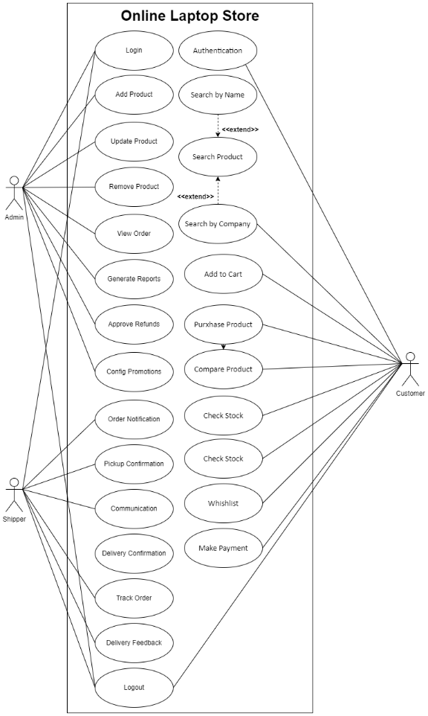

Figure ‑ Use case diagram for online laptop store

## Activity diagram and Swimlane diagram

2.2.1 Activity diagram for Order

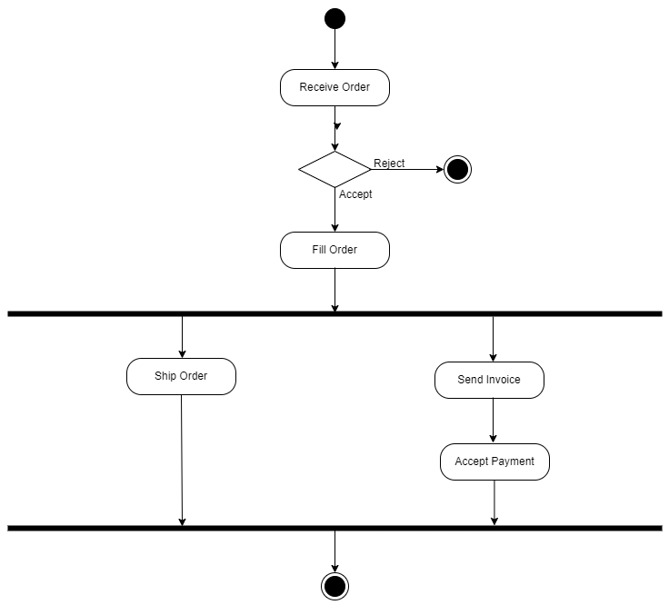

Figure ‑ Activity diagram for Order

2.2.2 Activity diagram for Payment

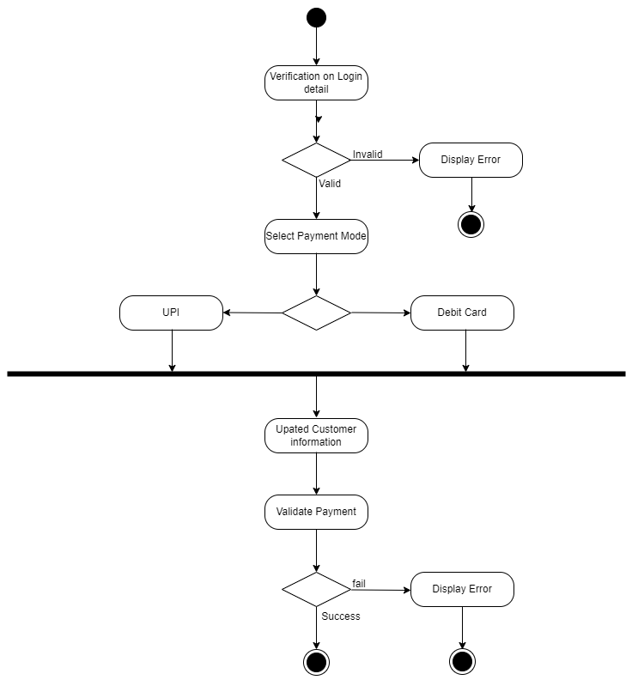

Figure ‑2 Activity diagram for Payment

2.2.3 Swimlane diagram for Payment

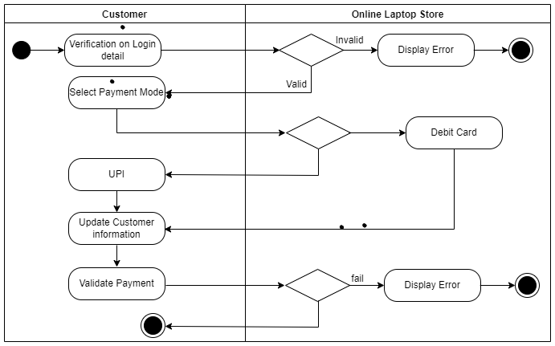

Figure ‑3 Swimlane diagram for Payment

## Sequence diagram

2.3.1 Sequence diagram for Order

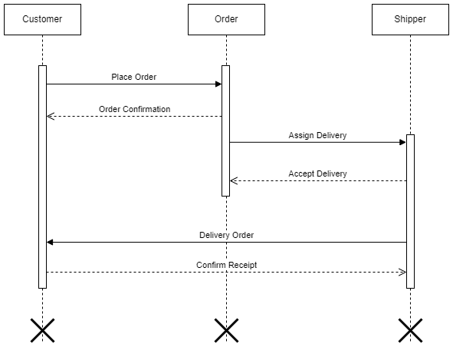

Figure ‑ Sequence diagram for Order

2.3.2 Sequence diagram for View Product

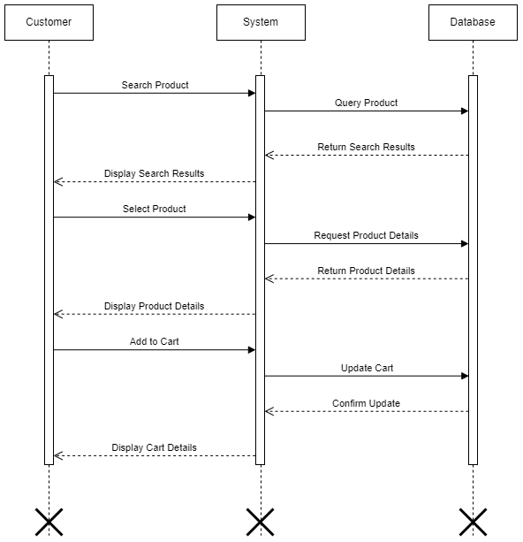

Figure ‑2 Sequence diagram for View Product

## State diagram

2.4.1 State diagram for Login

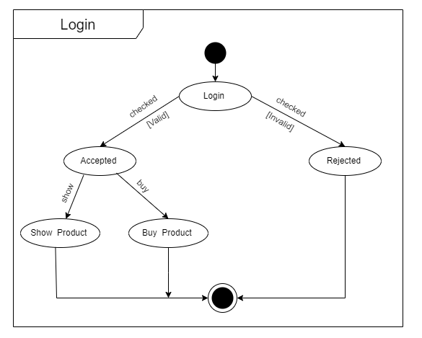

Figure ‑ State diagram for Login

2.4.2 State diagram for Order

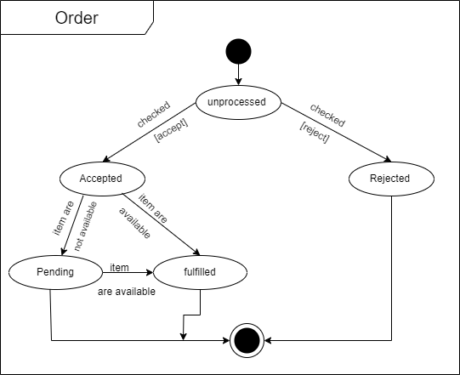

Figure ‑2 State diagram for Order

## Class diagram

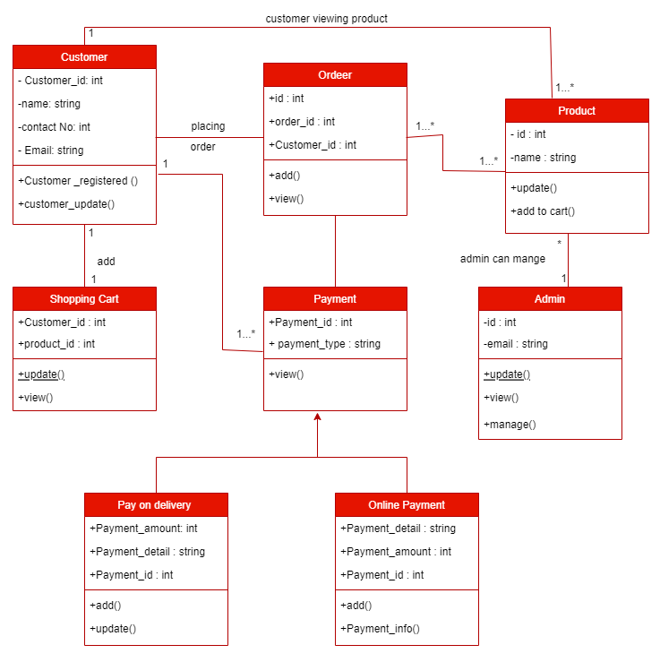

Figure ‑ Class diagram for Online Laptop Store

## Data flow diagram

### Context diagram (level-0)

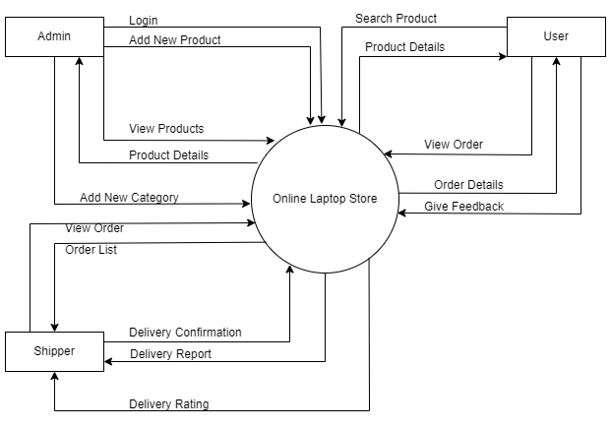

Figure ‑ Context diagram for Online Laptop Store

### DFD Level-1

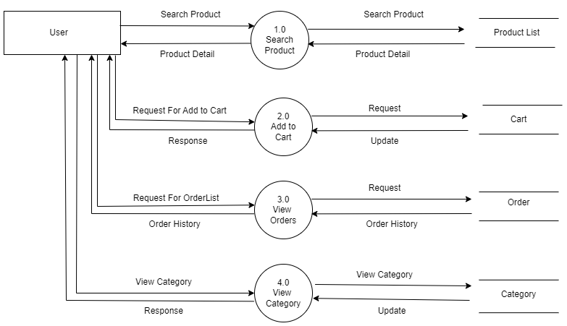

Figure ‑ DFD level-1 for Library management system

# External interface requirement (Screens)

## Screen-1: Order Cancellation

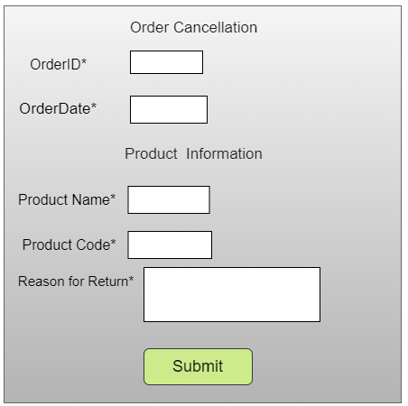

Figure ‑ Screen-1: Order Cancellation

**Purpose:** The purpose of the order cancellation screen is to allow users to cancel their orders seamlessly while providing reasons for cancellation and any necessary refund or return details.

Table ‑ Screen element of Order Cancellation

|  |  |  |  |  |  |
| --- | --- | --- | --- | --- | --- |
| Sr. | Screen Element | Input Type | O/M | 1/N | Description |
| 1 | Order ID | Textbox | M | 1 | Displays the unique order identifier; should be non-editable. |
| 2 | Order Date | Textbox | M | 1 | Displays the date when the order was placed; should be non-editable. |
| 3 | Product Name | Textbox | M | 1 | Displays the name of the ordered product; should be non-editable. |
| 4 | Product Code | Textbox | M | 1 | Displays the unique product code of the ordered item; should be non-editable. |
| 5 | Reason for  Return | Textbox | M | 1 | Allows users to enter the reason for cancelling the order. |
| 6 | Submit | Button | ------ | ------ | Confirms the order cancellation request and submits the details. |

## Screen-2: Payment Mode

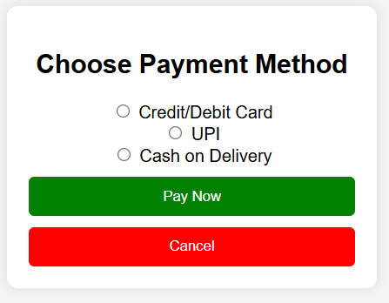

Figure 3.2‑ Screen-2: Payment Mode

**Purpose:** The purpose of the payment mode screen is to allow users to select their preferred payment method seamlessly while dynamically displaying relevant input fields and ensuring a smooth checkout experience.

Table ‑ Screen element of Payment Mode

|  |  |  |  |  |  |
| --- | --- | --- | --- | --- | --- |
| Sr. | Screen Element | Input Type | O/M | 1/N | Description |
| 1 | Credit/Debit Card | Radio Button | M | 1 | Allows users to select the Credit/Debit Card payment option. |
| 2 | UPI | Radio Button | M | 1 | Allows users to select UPI as the payment method. |
| 3 | Cash on Delivery | Radio Button | M | 1 | Enables users to opt for Cash on Delivery as the payment mode. |
| 4 | Pay Now | Button | ------ | ------ | Confirms the selected payment method and proceeds with the payment. |
| 5 | Cancel | Button | ------ | ------ | Allows users to cancel the payment process and return to the previous screen. |

## Screen-3: Add New Product

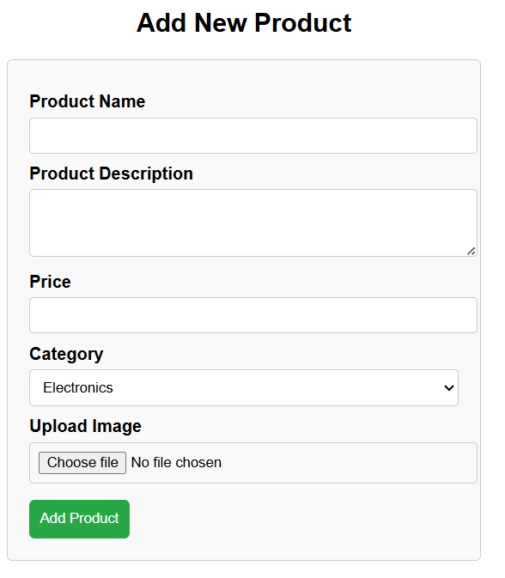

Figure 3.3‑ Screen-3: Add New Product

**Purpose:** The purpose of the Add New Product page is to enable users to quickly add products with key details, ensuring accurate listings and a better shopping experience.

Table 3.3‑ Screen element of Add New Product

|  |  |  |  |  |  |
| --- | --- | --- | --- | --- | --- |
| Sr. | Screen Element | Input Type | O/M | 1/N | Description |
| 1 | Product Name | Textbox | M | 1 | Allows users to enter the name of the product. |
| 2 | Product Description | Text area | M | 1 | Enables users to provide details about the product. |
| 3 | Price | Textbox | M | 1 | Allows users to enter the product price. |
| 4 | Category | Dropdown | M | 1 | Let’s users select the appropriate category for the product. |
| 5 | Upload Image | File | M | 1 | Enables users to upload an image of the product. |
| 6 | Add Product | Button | ------ | ------ | Submits the product details to be added to the system. |

## Screen-4: Add New Category

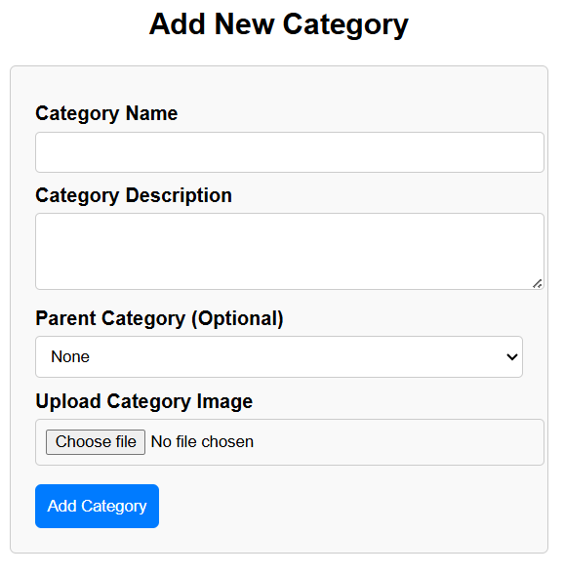

Figure 3.4‑ Screen-4: Add New Category

**Purpose:** The purpose of the Add New Category screen is to allow users to create and organize product categories by providing a name, description, parent category, and image for better product management.

Table 3.4‑ Screen element of Add New Category

|  |  |  |  |  |  |
| --- | --- | --- | --- | --- | --- |
| Sr. | Screen Element | Input Type | O/M | 1/N | Description |
| 1 | Category Name | Textbox | M | 1 | Allows users to enter the name of the category. |
| 2 | Category Description | Text Area | M | 1 | Enables users to provide details about the category. |
| 3 | Parent Category | Dropdown | M | 1 | Let’s users select a parent category (if applicable). |
| 4 | Upload Category Image | File | M | 1 | Allows users to upload an image representing the category. |
| 5 | Add Category | Button | ------ | ------ | Submits the category details to be added to the system. |

## Screen-5: Feedback Form

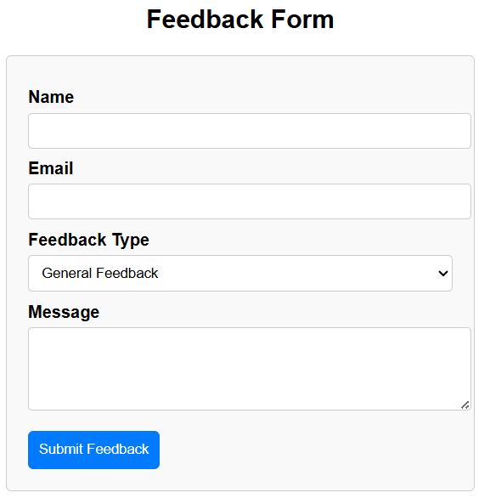

Figure 3.5‑ Screen-5: Feedback Form

**Purpose:** The purpose of the Feedback Form screen is to allow users to share their opinions, report issues, and provide suggestions, helping improve services, products, or user experiences.

Table 3.5‑ Screen element of Feedback Form

|  |  |  |  |  |  |
| --- | --- | --- | --- | --- | --- |
| Sr. | Screen Element | Input Type | O/M | 1/N | Description |
| 1 | Name | Textbox | M | 1 | Allows users to enter their name. |
| 2 | Email | Textbox | M | 1 | Enables users to provide their email address for communication. |
| 3 | Feedback Type | Dropdown | M | 1 | Lets users select the type of feedback they are submitting. |
| 4 | Message | Text area | M | 1 | Allows users to write detailed feedback, suggestions, or issues. |
| 5 | Submit Feedback | Button | ------ | ------ | Submits the feedback form for review and action. |

# Database design

## List of Tables

* Users
* Products
* Orders
* Payment
* Categories

Table ‑ Table: Users

|  |  |  |  |  |
| --- | --- | --- | --- | --- |
| Column | Data Type | Null | Keys & Constrains | Default Value & Description |
| UserID | int | NN | PK (Auto Increment) |  |
| Name | varchar(100) | NN |  |  |
| Email | varchar(100) | AN | Unique |  |
| Password | varchar(255) | AN |  | Hashed password storage |
| Phone | varchar(20) | AN |  |  |

Table ‑ Table: Products

|  |  |  |  |  |
| --- | --- | --- | --- | --- |
| Column | Data Type | Null | Keys & Constrains | Default Value & Description |
| ProductID | int | NN | PK (Auto Increment) |  |
| CategoryID | int | NN | FK (Categories) |  |
| Name | varchar(150) | NN |  |  |
| Description | Text | AN | Unique |  |
| Price | decimal(10.2) | AN |  |  |
| Stock | int | AN |  | Quantity available |

Table ‑ Table: Orders

|  |  |  |  |  |
| --- | --- | --- | --- | --- |
| Column | Data Type | Null | Keys & Constrains | Default Value & Description |
| OrderID | int | NN | PK (Auto Increment) |  |
| UserID | int | NN | FK (Users) |  |
| TotalPrice | decimal(10.2) | NN |  |  |
| Status | varchar(50) | AN |  | (Pending, Shipped, Delivered) |
| Created_at | Timestamp | AN |  | CURRENT_TIMESTAMP |

Table ‑ Table: Payment

|  |  |  |  |  |
| --- | --- | --- | --- | --- |
| Column | Data Type | Null | Keys & Constrains | Default Value & Description |
| PaymentID | int | NN | PK (Auto Increment) |  |
| OrderID | int | NN | FK (Categories) |  |
| UserID | Int | NN | FK (Users) |  |
| Amount | decimal(10,2) | AN |  |  |
| PaymentMethod | varchar(50) | AN |  | (Credit card, UPI, COD) |

Table -5 Table: Categories

|  |  |  |  |  |
| --- | --- | --- | --- | --- |
| Column | Data Type | Null | Keys & Constrains | Default Value & Description |
| CategoryID | Int | NN | PK (Auto Increment) |  |
| Name | varchar(100) | NN | Unique |  |
| Description | text | NN |  |  |

# Stories and Scenario

## Story-1: Successful Payment

|  |  |  |
| --- | --- | --- |
| *Story # S1* | : | As a customer,  I want to make a successful payment for my online purchase.  So that I can make payment method. |
| Priority | **:** | High |
| Estimate | **:** | XXL |
| Reason | **:** | The development of a payment page is complex task because it involve calculation of amount based on product type, product count in the Kitchen Accessories Management System. |

### Scenario# S1.1

|  |  |  |
| --- | --- | --- |
| *Scenario# S1.1* | : | Credit Card Payment |
| Prerequisite | **:** | User has items in the cart and is on the payment page. |
| Acceptance Criteria | **:** | **Given:** Enter valid credit card details (card number, expiration date, CVV).  **When:** Click on the "Pay Now" button.  **Then:** Payment is successful, and the user receives a confirmation message. The order is processed. |

### Scenario# S1.2

|  |  |  |
| --- | --- | --- |
| *Scenario# S1.2* | : | PayPal Payment |
| Prerequisite | **:** | User has items in the cart and is on the payment page. |
| Acceptance Criteria | **:** | **Given:** Customer navigate to the payment page.  **When:**   * Click on the "Pay with PayPal" button. * Log in to the PayPal account. * Authorize the payment.   **Then:** Payment is successful, and the user receives a confirmation message. The order is processed. |

### Scenario# S1.3

|  |  |  |
| --- | --- | --- |
| *Scenario# S1.3* | : | Invalid Credit Card Details |
| Prerequisite | **:** | User has items in the cart and is on the payment page. |
| Acceptance Criteria | **:** | **Given**: Enter invalid credit card details (e.g., incorrect card number, expired card).  **When**: Click on the "Pay Now" button.  **Then** : Payment fails, and the user receives an error message indicating the issue with the card details. |

## Story-2: Registration Form

|  |  |  |
| --- | --- | --- |
| *Story # S2* | : | As a customer,  I want to verify that a user can successfully register on the website.  So that I can make registration form. |
| Priority | **:** | High |
| Estimate | **:** | XL |
| Reason | **:** | To verify that the registration form properly handles errors and displays appropriate messages. |

### Scenario# S2.1

|  |  |  |
| --- | --- | --- |
| *Scenario# S2.1* | : | Successful User Registration |
| Prerequisite | **:** | User on the registration form. |
| Acceptance Criteria | **:** | **Given:** I am on the registration page  **When:** I fill in valid and unique registration information (email, password, username, etc.) and I click the "Register" button.  **Then:** I should see a confirmation message**.** |

### Scenario# S2.2

|  |  |  |
| --- | --- | --- |
| *Scenario# S2.2* | : | Registration Error Handling |
| Prerequisite | **:** | User on the registration form. |
| Acceptance Criteria | **:** | **Given**: I am on the registration page  **When:** I submit the form with missing required fields (e.g., leaving email and password fields empty).  **Then:** I should see validation messages for the missing fields. and I should not be registered. |

### Scenario# S2.3

|  |  |  |
| --- | --- | --- |
| *Scenario# S2.3* | : | Password Strength |
| Prerequisite | **:** | User on the registration form. |
| Acceptance Criteria | **:** | **Given**: I am on the registration page.  **When:** I enter a weak password (e.g., too short or lacking complexity).  **Then**: I should see a validation message for the password field. and I should not be able to submit the form. |

# Test cases

|  |  |  |  |
| --- | --- | --- | --- |
| Project Name: | Online Laptop Store | Test Designed by: | P. M. Dadhaniya |
| Module Name: | **Login** | **Test Designed date:** | 09-03-2025 |
| Release Version: | **1.0** | **Test Executed by:** | **R. B. Gondaliya** |
|  |  | **Test Execution date:** | 09-03-2025 |

|  |  |  |  |  |
| --- | --- | --- | --- | --- |
| Pre-condition: Web application should be accessible | | | | |
| Test Case ID | **Test Title** | **Test Type** | **Description** | **Test Case ID** |
| TC_001 | Add product to cart | Functional | Add a product to the shopping cart | TC_001 |
| TC_002 | Remove product  from cart | Functional | Remove a product from the shopping cart | TC_002 |

|  |  |
| --- | --- |
| **Test Case Title** | Add product to cart |
| **Test Type** | Functional |
| **Test Priority** | High |
| **Pre-condition** | Web application should be accessible |

|  |  |  |  |  |  |  |  |
| --- | --- | --- | --- | --- | --- | --- | --- |
| **Test Step** | **Test Case Description** | **Expected Result** | **Actual Result** | **Status** | **Comment** | **Data** | **BUG ID** |
| 1 | Navigate to the product  page | Product page should be  displayed | Product page displayed  successfully | Pass |  | https:onlineshop ping.com/addto cart |  |
| 2 | Select a  product from the list | Product details  page should be displayed | Product  details page opened | Pass |  |  |  |
| 3 | Click on "Add to  Cart"  button | Product should be added to the cart | Product added successfully | pass |  |  |  |
| 4 | Go to the cart page | Cart page should display  added product | Cart page  displayed  correctly | Pass |  |  |  |

|  |  |
| --- | --- |
| **Test Case Title** | Remove product from cart |
| **Test Type** | Functional |
| **Test Priority** | Medium |
| **Pre-condition** | Web application should be accessible, and at least one product should be in  the cart. |

|  |  |  |  |  |  |  |  |
| --- | --- | --- | --- | --- | --- | --- | --- |
| **Test Step** | **Test Case Description** | **Expected Result** | **Actual Result** | **Status** | **Comment** | **Data** | **Bug ID** |
| 1 | Navigate  to the  cart page | Cart page  should  display  added  product | Cart page  displayed  successfully | Pass |  |  |  |
| 2 | Verify  that the  product  details  (name, price,  quantity)  are visible | Product details should be displayed correctly | Product  details are  visible | Pass |  |  |  |
| 3 | Click on  "Remove"  button  for a  product | Product  should be  removed  from the  cart | Product  removed  successfully | Pass |  |  |  |
| 4 | Verify  that the  cart  updates  and the  removed  product is  no longer  Visible | Cart should update and removed product should disappear | Cart updated; product removed | Pass |  |  |  |

|  |  |  |  |  |  |  |  |
| --- | --- | --- | --- | --- | --- | --- | --- |
| **Pre-condition: Web application should be accessible** | | | | | | | |
| **Test Case ID** | **Test Title** | | **Test Type** | **Description** | | | **Test Case ID** |
| **TC_003** | Enter shipping address | | Functional | Enter user shipping address for order placement | | | TC_003 |
| **TC_004** | Verify address form elements | | GUI | Ensure all address form elements are present and functional | | | TC_004 |
| **Project Name:** | | **Online Shopping** | | | **Test Designed by:** | **Karan Sonagara** | |
| **Module Name:** | | **Address Form** | | | **Test Designed date:** | 22-02-2025 | |
| **Release Version:** | | **1.0** | | | **Test Executed by:** | **R. B. Gondaliya** | |
|  | |  | | | **Test Execution date:** | 15-01-2023 | |

|  |  |
| --- | --- |
| Test Case Title | Enter shipping address |
| Test Type | Functional |
| Test Priority | High |
| Pre-condition | Web application should be accessible |

|  |  |  |  |  |  |  |  |
| --- | --- | --- | --- | --- | --- | --- | --- |
| Test  Step | Test Case  Description | Expected Result | Actual Result | Status | Comment | Data | BUG ID |
| 1 | Navigate to the checkout  page | Checkout page should be displayed | Checkout page displayed  successfully | Pass |  |  |  |
| 2 | Enter Name in the Name  field | Name field should accept  input | Name entered  successfully | Pass |  |  |  |
| 3 | Enter Address Related  Detail Enter | Address related field should accept  input | Address form loaded | Pass |  |  |  |
| 4 | Click on the "Submit" button | Address should be saved, and the user should proceed to the  next step | Address saved successfully | Pass |  |  |  |

|  |  |
| --- | --- |
| Test Case Title | Verify address form elements |
| Test Type | GUI |
| Test Priority | Medium |
| Pre-condition | Web application should be accessible |

|  |  |  |  |  |  |  |  |
| --- | --- | --- | --- | --- | --- | --- | --- |
| Test  Step | Test Case  Description | Expected Result | Actual Result | Status | Comment | Data | BUG ID |
| 1 | Navigate to  the address form page | Address form  page should be displayed | Address form  displayed successfully | Pass |  |  |  |
| 2 | Verify presence of Name, Mobile No, Email ID  fields | All fields should be present | Fields are present | Pass |  |  |  |
| 3 | Verify that the "Submit" button is  enabled | Submit button should be enabled | Button is enabled | Pass |  |  |  |
| 4 | Verify field validation for empty  input | Fields should show error messages for  blank input | Validation messages displayed | Pass |  |  |  |

# References

* http://www.w3schools.com/html/html_intro.asp
* https://www.w3schools.com/php/default.asp
* https://www.javatpoint.com/uml